Meta Title:
Buy Pre-Owned Girard Perregaux Watches | Swiss Ice
Meta Description:
Shop pre-owned Girard Perregaux watches at Swiss Ice Co. Visit our San Francisco or Los Angeles stores for authentic collections and exceptional deals.
Watches GIRARD-PERREGAUX | https://swissiceco.com/collections/watches-girard-perregaux | girard perregaux watch  Buy Pre Owned Girard Perregaux  Men girard perregaux watch  girard perregaux watch for sale

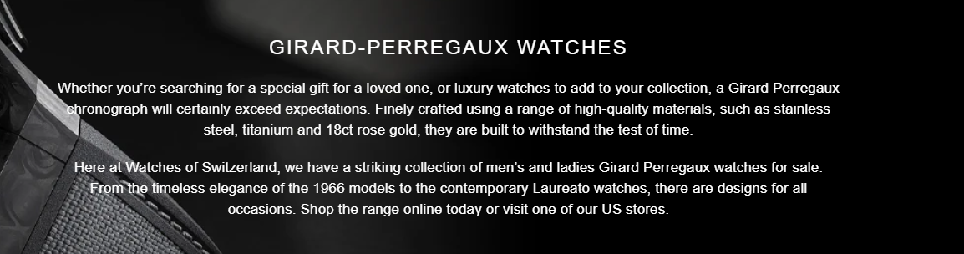Girard Perregaux Watch
Welcome to Swiss Ice Co where you will find a complete range of vintage Girard Perregaux Watches, that are made to the highest standards. If you are looking for a Men’s Girard Perregaux or if you want to buy pre owned Girard Perregaux then you will be totally amazed with our beautiful Girard Perregaux collection.

Shop Now

History of Girard Perregaux:
Girard Perregaux is a traditional Swiss watch manufacturer which is considered to be the industry leader since 1856. This brand is widely known for its legendary name attributed to its very strict focus on the true art of Swiss watchmaking. Moreover, this brand aims to merge sophistication and intellect to bring through a line of watches that are not only aesthetically good but also functional. Girard Perregaux has been known for the manufacturer’s ability to construct timepieces that not only tell time with incredible accuracy but are also pieces of art to be worn.

Get Attention With Our Men’s Girard Perregaux Collection:
The Men’s Girard Perregaux section of our collection includes numerous models of watches made from the finest materials by the hands of skilled craftsmen. Starting from dress watches and going to sporty chronographs, every model represents the spirit of the Girard Perregaux brand. Gain an insight into tradition in conjunction with tradition feels with our current range of Girard Perregaux watches for sale. Every man’s models demonstrate all the hallmarks of brand identity and are fitted with intricate movements and intricate finishing.

Get the Highest Standard Luxury Pre Owned Watches:
Those who want to buy pre owned Girard Perregaux can find a list of good pre-owned watches for sale in our store, all of them being certified. Every single product is carefully scrutinized to make certain that it can meet our high standards of quality. So, you have the privilege to receive a perfectly fine timepiece that has been lightly worn and is now waiting for you to put it on. Our luxury pre-owned Girard Perregaux wristwatches are not new but are superb and within a reasonable price bracket offer an excellent chance to own something elegant. Visit Swiss Ice Co today and learn more about vintage and second-hand Girard Perregaux watches and find one that harmonizes with your personality.

Experience the True Masterpiece of Horology Wonders:

Swiss watches are a masterpiece that represents the masters who built these amazing wonders of horology. Ever since it was established in 1791, Girard Perregaux Manufacture has been developing its skills and offering a classical collection of timepieces both stunning and highly effective. If you cannot find a specific Girard Perregaux model that you’re looking for, please feel free to contact us anyway. We have every famous model in our collection that is ready to own by you.

Feel the Difference In Every Inch:
When it comes to purchasing a pre owned Girard Perregaux watch for sale then make sure you buy it from a trusted source like Swiss Ice Co.. All pieces available in our collection are thoroughly checked for their quality so that you surely receive a beautifully used and ready-to-wear timepiece. Our Girard Perregaux watches are the ideal way to get a piece of horological history at true value prices. You can find a wide range of pre-owned watches from our San Francisco and Los Angeles stores to get the watch that is best suited to your taste.

Ready to Own Your Next Girard Perregaux watch:
If you are considering buying a Girard Perregaux watch, Swiss Ice Co is a perfect place for that. Our collection of Men’s Girard Perregaux watches and pre-owned models will perfectly do representation of your taste and personality. Breathtaking craftsmanship, precise workmanship, and timeless quality epitomize the essence of our watches. So, shop now for a sophisticated watch at Swiss Ice Co.
